**CIS 476-001**

**Project 2**

**UML Class Diagram & Scenarios Screenshots**

**Name: Athira Nakkara Radhakrishnan**

**Date: 11/11/2024**

**UML Class diagram**

**Screenshots showing different execution** **scenarios**

**Scenario 1: Successful Bid for a Suite**

* Bid Price: $300
* Room count update: Suite room count decreased by 1

**Scenario 2: Successful Bid for a** **Deluxe Room**

* Bid Price: $200
* Room count update: Deluxe room count decreased by 1

**Scenario 3: Successful Bid for a** **Standard Room**

* Bid Price: $100
* Room count update: Standard room count decreased by 1

**Scenario 4: Suite Rooms sold out; Bid Accepted for Deluxe**

* Bid Price: $300
* Room count update: Deluxe room count decreased by 1

**Scenario 5: Suite and Deluxe sold out; Bid Accepted for Standard**

* Bid Price: $300
* Room count update: Standard room count decreased by 1

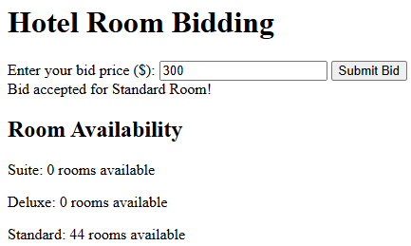

**Scenario 6: All types of Rooms Sold Out**

* Bid Price: $300
* Room count: Suite = 0, Deluxe = 0, Standard = 0

**Scenario 7: Bid below Minimum for all room types**

* Bid Price: $70
* Room count: No change in the room count

**Scenario 8: Bid at Minimum Price for Suite Room**

* Bid Price: $280
* Room count: Suite room count decreased by 1

**Scenario 9: Bid at Minimum Price for Deluxe Room**

* Bid Price: $150
* Room count: Deluxe room count decreased by 1

**Scenario 10: Bid at Minimum Price for Standard Room**

* Bid Price: $80
* Room count: Standard room count decreased by 1

**Scenario 11: Bid for Deluxe when suite Room is Available**

* Bid Price: $250
* Room count: Deluxe room count decreased by 1

**Scenario 12: Bid for Standard when Deluxe and Suite Rooms are Available**

* Bid Price: $120
* Room count: Standard room count decreased by 1

